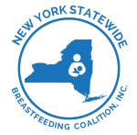
New York Statewide Breastfeeding Coalition, Inc.
PO Box 61 Delmar, NY 12054
www.nysbreastfeeding.org nysbcinc@gmail.com

